Council Tax Support Review

Consultation Feedback Report

September 2014

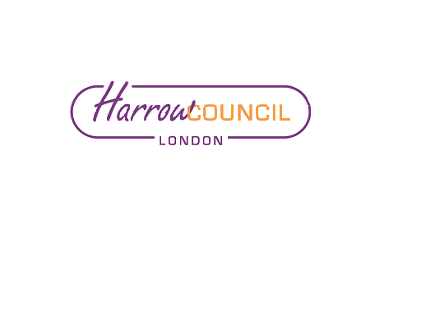

CONTENTS
Page
1. Executive Summary 3
2. Background 5
3. Consultation Process 8
3.1 Consultation Methodology 8
3.2 Consultation Questionnaire 9
3.3 Events 10
3.4 Organisational Promotion 10
3.5 Formal Stakeholder Feedback 11
4. Consultation Feedback 12
4.1 Questionnaire 12
4.2 Questionnaire Additional Comments 26
4.3 Event Feedback 27
4.4 Formal Stakeholder Feedback 29
4.5 Petition 32
5. Monitoring Information 33
6. Next steps 41
Appendices
Appendix A Consultation booklet
Appendix B Consultation questionnaire
Appendix C Questionnaire feedback on groups affected
Appendix D Questionnaire feedback on other groups affected
Appendix E Questionnaire additional comments
Appendix F Schedule of consultation events
Appendix G Event feedback
Appendix H Organisation formal responses
Appendix I Schedule of organisations invited to promote consultation
Appendix J Petition with covering letter

1.0 EXECUTIVE SUMMARY

  - Introduction

1.2 Due to cuts in government funding Harrow Council must make savings of £75 million over the next four years and as a result has determined that it needs to identify up to £2m in savings from its Council Tax Support Scheme from 2015/16 onwards.

1.3 For a 10 week period, from 7th July to 12th September 2014, the Council consulted on proposed methods of achieving the savings within the Council Tax Support Scheme. The Council is committed to ensuring residents get the opportunity to give their views and shape services and therefore the Council consulted with existing claimants, residents and stakeholder organisations within Harrow. To ensure as many residents in Harrow got the opportunity to be involved a substantial number of local organisations were invited to help promote the consultation process.

1.4 A multi-agency Community Reference Group was included in the governance structure and their role was to help the Council ensure the consultation was inclusive and transparent. The group helped to set up events with users of their services and also fed into the development of the Equalities Impact Assessment. The group includes representation from organisations such as Citizens Advice Bureau, Harrow Association for Disabled, MIND in Harrow, Harrow Mencap, Harrow Law Centre, elected members and council services as well as various other stakeholders.

1.5 The Consultation

1.6 The Council is required by legislation to consult with the major preceptor, the Greater London Authority (GLA). To meet this requirement, the Greater London Authority were notified of the Council’s decision to consult and invited to feed into the process.

1.7 A letter which included the consultation document and survey was sent to 20,000 working age Council Tax Support recipients and a random sample of Council Tax payers. To ensure that as many people as possible got the opportunity to be involved and to have their sav 31 face to face meetings were held across Harrow, which included roadshows, drop in events, workshops and attendance at community group meetings.

1.8 Within the consultation the council set out four proposed Council Tax Support Schemes. Each individual scheme was developed in a different way, with different rules that impact different groups of claimants, however all generated the potential £2 million savings target. Respondents were asked to identify whether they thought the Council should adopt each scheme, and were asked to identify which groups they thought might be affected by the individual schemes and why. Respondents were also asked whether the changes should be phased in over a period of time.

1.9 The feedback received at the face to face meetings gave the Council the opportunity to understand in depth the impacts of the proposed changes and gave further context to the questionnaire submissions.

1.10 Formal feedback to the consultation was received from five organisations: Harrow Citizens Advice Bureau, Harrow Law Centre, Harrow Mencap, Zaccaeus 2000/Child Poverty Action Group (Z2K/CPAG) and the preceptor Greater London Authority (GLA).

1.11 A petition containing 411 signatures was also submitted stating the signatories were opposed to the proposals.

1.12 Summary of the Consultation Feedback

1.13 Respondents were not asked to choose their preferred scheme however were asked to tick if they agreed a scheme should be adopted and therefore could tick none, one or more of the four proposed Council Tax Support models put forward. Feedback to the consultation showed that proposed Scheme 3 was the model with the highest number of ‘Yes’ responses and fewest number of ‘No’ in the questionnaires. Whilst there were significantly more ‘No’ than ‘Yes’ responses for Proposed Schemes 1, 2 and 4, Scheme 3 still has less than 50% in favour. This could therefore be interpreted as Scheme 3 being the least disliked of the four put forward in the consultation. Furthermore, four of the formal respondents, excluding the GLA who made no specific comment on the proposed schemes, stated that they were unable to select any of the four schemes because of the impacts of the proposed changes for recipients of Council Tax Support.

1.14 Respondents believed that schemes 1, 2 and 4 would have greatest impact on disabled households and large families, while scheme 3 was thought to have most impact on large and small families and people in work. Feedback from the events and formal feedback identified that the vulnerable, disabled and those at the bottom of the ladder would be most harshly impacted by the proposals. People also voiced concerns about affordability for those affected and the increased risk for people getting in to debt.

1.15 The consultation also asked people whether changes to the Council Tax Support scheme should be implemented in full from April 2015, or phased in over two or more years starting in April 2015. While some, including Zaccaeus 2000/Child Poverty Action Group, stated that the changes should not be implemented at all making them unable to respond to this question, 34% of people who did respond said the changes should be implemented in full from April 2015 and 40% stated a phased approach should be adopted.

REVIEW OF COUNCIL TAX SUPPORT SCHEME – FULL CONSULTATION REPORT

2.0 Background

2.1 In April 2013 Council Tax Support replaced Council Tax Benefit as a local assistance for payment of Council Tax. Council Tax Support is claimed by residents who have a low income and meet certain criteria. Whilst the rules for Council Tax Support are agreed locally there are also some national criteria that Local Authorities must follow. Pensioners have not been affected by the introduction of Council Tax Support and continue to sit under a national scheme.

2.2 Council Tax Benefit was previously fully funded through a central government grant. When Council Tax Support was localised in April 2013 there was a 10% cut in the funding. There is no additional funding available to respond to increased pressure on the funding pot for example due to a growth in the number of claims. Following extensive consultation with residents, Harrow agreed a 2-year scheme from 1st April 2013 that matched the available funding, resulting in working age recipients of Council Tax Support receiving less help towards their Council Tax than they previously received through Council Tax Benefit.

2.3 Harrow Council is required by law to consider whether the scheme for 2015/16 should be revised. In doing this, the Council needs to take into account its overall financial position, as well as other related external factors; for example, its duties to vulnerable residents and Department of Communities and Local Government (DCLG) guidance which states that local authorities should align their schemes with the central government drive to incentivise work.

2.4 In 2014/15 Harrow Council expects to allocate £15.5m to Council Tax Support for approximately 15,500 working age households. Given the severe funding gap that the Council faces, with £75 million to be saved by 2018/19, it was considered appropriate to review the scheme. The aim is to secure a reduction in Council Tax Support expenditure to the local authority of up to £2 million over 1-4 years, commencing in 2015/16.

2.5 Harrow’s Council Tax Support scheme has 3 groups of claimants:

- Pensioners (who are not affected by these changes and under legislation are still protected up to 100% of their Council Tax bill)
- Working Age Disabled and War Widows Pensioners in receipt of certain benefits
- All other Working Age

All working age households in the borough have to pay something toward their council tax.

2.6 £2 million savings can only be achieved by changing certain rules within the scheme, for example the Liability Cap or including child benefit as income. Each change will have a different impact on working age groups of claimants, pensioners excluded. The Council has developed 4 possible alternative schemes to demonstrate how the rules of the scheme can be altered to find the saving. Each model has a different impact on different groups.

2.7 In order to ensure that residents and stakeholders had an opportunity to feed into the development of the revised Council Tax Support scheme Harrow Council undertook a wide-ranging consultation process. This report summarises the outcome of this consultation process.

2.8 The 4 model schemes considered in the consultation process are shown in the table below. Further detail on each of these models is included in the consultation booklet in Appendix A.

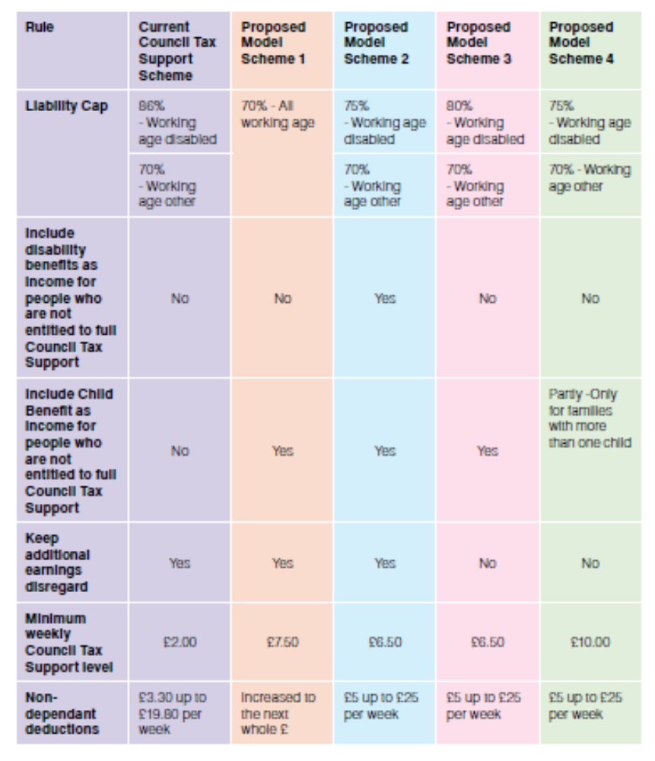

2.9 The financial implications of each model on the different groups are averaged in the table below, and are also included in the consultation booklet in Appendix A.
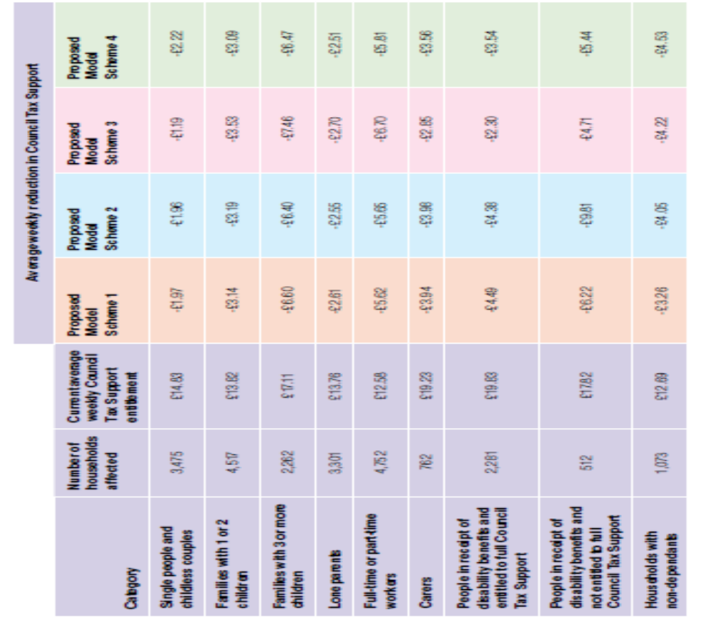

3. Consultation Process

3.1 Consultation Methodology

3.1.1 Legislation states that the local authority must consult with major preceptors when reviewing the Council Tax Support scheme. Harrow Council therefore notified the Greater London Authority (GLA) of the review and gave an opportunity to feed into the consultation. The Greater London Authority (GLA) submitted a formal response which is in appendix H.

A multi-agency Community Reference Group worked with the Council to ensure the consultation was inclusive by:

- Being given the opportunity to review the consultation documents prior to the launch of the consultation
- Identifying any gaps in the consultation to enable events to be scheduled
- Holding events with their clients
- Raising awareness of the consultation with their clients
- In partnership with Harrow Mencap development of an Easy Read version of the consultation documents
- Feeding into the Equality Impact Assessment for example via a sub-group

In addition to elected members the Community Reference group includes representation from the following organisations/groups:

- Citizens Advice Bureau
- Harrow Law Centre
- MIND in Harrow
- Harrow Mencap
- Harrow Association for Disabled
- Age UK
- Harrow Carers
- Harrow Refugee & Minorities Forum
- Harrow Equalities Centre
- Harrow Association of Somali Voluntary Organisations
- Capable Communities
- CNWL
- Job Centre Plus
- Registered Social Landlords
- Landlords Federation
- Council officers from services including Benefits, Council Tax, Housing, Economic Development, Community, Health & Wellbeing, Access Harrow

The Communication and Consultation Strategy ensured the consultation would create the opportunity for a broad representation of residents, including all Council Tax Support recipients and key stakeholders to give their views. To meet this outcome the consultation included the following:

- a mailshot of the consultation booklet and questionnaire was sent to 15,000 Council Tax Support recipients and a random sample of 5,000 other council tax payers,
- online consultation,
- Development of an Easy Read consultation document
- 31 drop in events, discussion groups and workshops
- Email & telephone
- Publicity via Facebook and Twitter, Council website, local newspapers, posters and flyers distributed throughout the borough

Supporting material has included a Consultation Booklet, Consultation Questionnaire, an Easy read version of the booklet and a consultation presentation.

3.1.2 Responses to the questionnaire were either submitted by hand at face to face events, posted back using FREEPOST or completed online at http://www.harrow.gov.uk/ctsconsultation

3.1.3 Feedback was captured at face to face events either on a one-to-one basis or in focus groups. In these forums residents and organisations were given an overview of the proposals and had the opportunity to ask questions to inform their response. Holding face to face discussions gave the Council the opportunity to discuss this complex subject in depth and gave opportunity for detailed feedback to be provided. All feedback from these face to face events/discussions was captured and has fed into this report.

Residents and organisations were also able to submit comments and questions through both email and telephone to Harrow Council. Comments made through these channels, whilst very few, are included in the Additional Comments in Appendix E, summarised in section 4.2.

3.1.4 Further information was also available on the Harrow Council website at www.harrow.gov.uk/ctsconsultation. The website received 1,734 ‘hits’ during the consultation period.

3.1.5 The consultation ran for a period of 10 weeks, from 7th July to 12th September 2014.

3.1.6 The outcome of this consultation is to be reported to Harrow Council Cabinet in December 2014 and full council in January 2015 when a final decision is to be made on the Council Tax Support scheme that is to be taken forward for 2015/16.

3.1.7 A copy of the Consultation Booklet is included in Appendix A.

3.2 Consultation Questionnaire

3.2.1 A total of 20,000 questionnaires were posted to all the existing Council Tax Support claimants and to randomly selected Council Tax payers who are non-Council Tax Support claimants in Harrow. The Council’s online customer account, ‘My Harrow’, was used as an engagement tool to reach all registered residents, who received emails and text alerts to remind them of the consultation in progress.

3.2.2 A copy of the Consultation Questionnaire is included in Appendix B.

3.3 Events

3.3.1 Harrow Council set up a number of dedicated drop-in events and attended a range of community events, stakeholder meetings and focus groups in order to both widen the consultation process and to allow face-to-face discussions and explanations to take place.

3.3.2 In all, consultation on the Council Tax Support scheme took place at 31 events/roadshows/focus groups, including:

- Children’s Centres
- MIND in Harrow service user event
- Harrow Association for Disabled service user event
- Job club
- Town Centre stalls
- Flash Musicals
- Council Tax Support staff team meeting
- Access Harrow

A full list of events is in Appendix F. The attendance at each of these events is included in the Appendix F and varied from 3 to over 1,000, dependent upon the type of event, the nature of the audience and the weather. The total attendance at these events exceeded 4,600.

3.4 Organisational Promotion

3.4.1 Harrow Council invited a wide range of organisations to help promote the consultation through the use of posters and through making booklets and questionnaires available to their users. There is a full listing of organisations in Appendix I. This included:

- Voluntary Agencies
- Supermarkets
- Libraries
- Religious Places
- Special Groups
- GPs, Hospitals, Dentists
- Housing Associations
- Playgroups or Pre-School
- Day Nurseries

3.4.2 Further meetings or email communication took place with MPs and Councillors.

The consultation was also publicised via local newspapers, Harrow People, Council website, My Harrow Account, Social media (Facebook & Twitter) and Access Harrow.

3.4.3 Meetings were also held with staff in a number of Service Departments within the Council, including Council Tax Support/Housing Benefits as well as with Job Centre Plus.

3.5 Formal Stakeholder Feedback

3.5.1 Stakeholder organisations were also able to submit a formal response to the consultation and as a result five formal responses were received including from the major preceptor, the Greater London Authority (GLA).

4. CONSULTATION FEEDBACK

4.1 Consultation Questionnaire

4.1.1 In total there were 230 responses to the questionnaire, of which 184 were paper returns and 46 were submitted online through the Council website.

4.1.2 The volume of questionnaire responses received is relatively low, at only 1% of the questionnaires sent out. This may be due in part to the complexity of the issue and the difficulty from a lay perspective of making an informed decision on the model options put forward. However, this was balanced by the significant number of events attended together with the meetings held with stakeholder organisations, where face-to-face discussion and explanation took place with a large number of people.

4.1.3 The questionnaire responses were recorded anonymously so as to ensure confidentiality.

4.1.4 The analysis in this section of the report is of the combined paper and online responses. It should be noted that respondents were able to state that the Council should adopt more than one scheme and, in doing so, did not have to nominate a preferred scheme.

4.1.5 Question 1a

Q: Do you think Harrow Council should adopt Proposed Scheme 1?

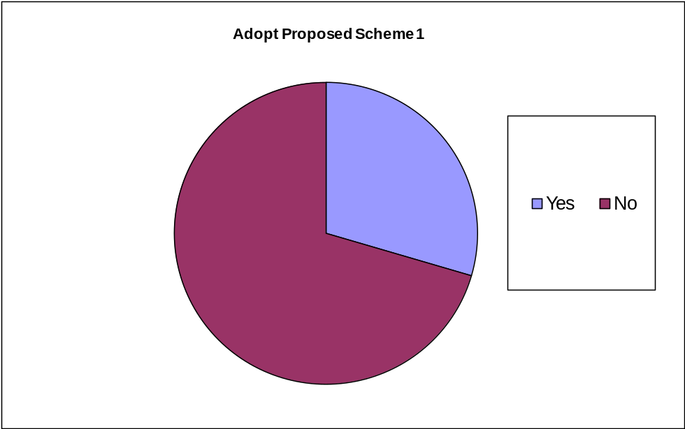

Adopt Proposed Scheme 1 | Number | Percentage  (of 230)
Yes | 57 | 25%
No | 136 | 59%
Blank | 37 | 16%

Q: Which of the following groups do you think will be disadvantaged by Proposed Scheme 1?

Respondents were given the opportunity to select more than one group.

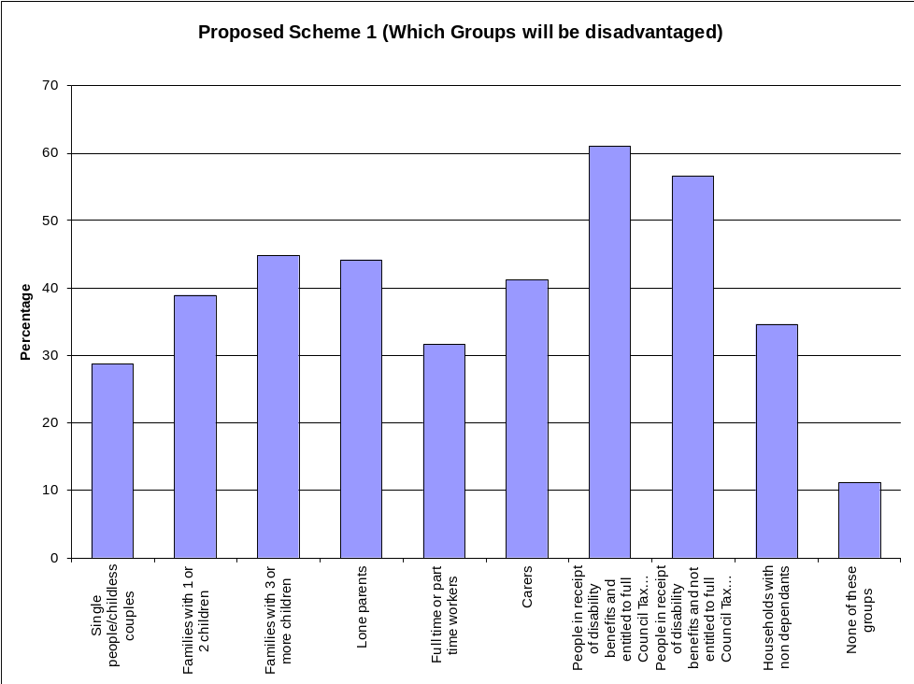

Group | Total | Percentage
Group | Total | (of 136)
Number of responses | 136
People in receipt of disability benefits and entitled to full Council Tax Support | 83 | 61%
People in receipt of disability benefits and not entitled to full Council Tax Support | 77 | 57%
Families with 3 or more children | 61 | 45%
Lone parents | 60 | 44%
Carers | 56 | 41%
Families with 1 or 2 children | 53 | 39%
Households with non-dependants | 47 | 35%
Full or part time workers | 43 | 32%
Single people/childless couple | 39 | 29%
None of these groups | 15 | 11%

The top three groups identified as being impacted by proposed scheme 1 were:

- People in receipt of disability benefits and entitled to full Council Tax Support
- People in receipt of disability benefits and not entitled to full Council Tax Support
- Families with 3 or more children

Q: Thinking about the groups which you have ticked ‘yes’ for above, please tell us why you think they will be affected.

Given the large volume of feedback to this question, the responses are included in full in Appendix C. The Table below gives a summary by topic.

Scheme 1 | Why you think they will be affected | Number
1 | Impact on Disabled (including due to Liability cap change) | 18
2 | Families will have financial difficulties | 15
3= | Affects all groups financially | 11
3= | Impact through increase in non-dependant deductions on households, carers and those unable to work | 11
4 | Impact on Working Age Disabled, especially those who can’t work | 9
5 | Impact on lone parents | 8
6 | For the financial reasons shown in Booklet Chart 4 | 5
7 | Those with Child Benefit as included as income | 4
8 | Impact on those on low or limited income | 2
9 | Impact on part timer workers | 1
10 | Full time workers to pay more | 1
11 | Should be based on income | 1
12 | Single people who pay same as larger groups | 1
The three most common reasons given as to why the identified groups are affected by Proposed Scheme 1 are:

- Impact on the Disabled (including due to Liability cap change)
- Families will have financial difficulties
3= Affects all groups financially
3= Impact through increase in non-dependant deductions on households, carers and those unable to work

4.1.6 Question 1b

Q: Do you think Harrow Council should adopt Proposed Scheme 2?

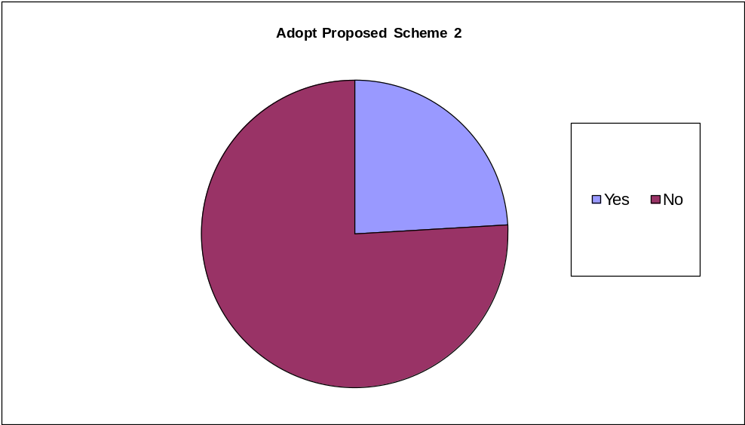

Adopt Proposed Scheme 2 | Number | Percentage  (of 230)
Yes | 45 | 20%
No | 142 | 61%
Blank | 43 | 18%

Q: Which of the following groups do you think will be disadvantaged by Proposed Scheme 2?

Respondents were given the opportunity to select more than one group.

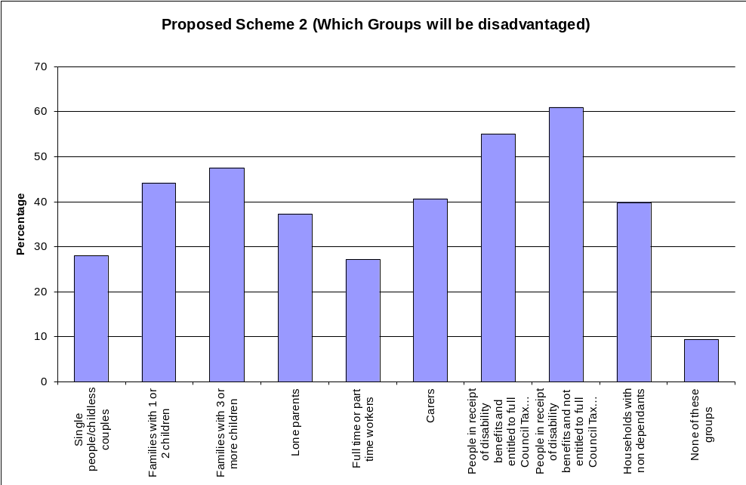

Group | Total | Percentage
Group | Total | (of 118)
Number of responses | 118
People in receipt of disability benefits and not entitled to full Council Tax Support | 72 | 61%
People in receipt of disability benefits and entitled to full Council Tax Support | 65 | 55%
Families with 3 or more children | 56 | 47%
Families with 1 or 2 children | 52 | 44%
Carers | 48 | 41%
Households with non dependants | 47 | 40%
Lone parents | 44 | 37%
Single people/childless couple | 33 | 28%
Full or part time workers | 32 | 27%
None of these groups | 11 | 9%

The top three groups identified as being impacted by proposed scheme 2 were:

- People in receipt of disability benefits and not entitled to full Council Tax Support
- People in receipt of disability benefits and entitled to full Council Tax Support
- Families with 3 or more children

Q: Thinking about the groups which you have ticked ‘yes’ for above, please tell us why you think they will be affected.

Given the large volume of feedback to this question, the responses are included in full in Appendix C. The Table below gives a summary by topic.

Scheme 2 | Why you think they will be affected | Number
1 | Impact on the Disabled as including DLA as income will further reduce income (already included in social care) | 21
2= | Families will have financial difficulties | 11
2= | Impact through increase in non-dependant deductions on households, carers and those unable to work | 11
3 | Affects all groups financially | 7
4 | Those with Child Benefit as included as income | 5
5 | For the financial reasons shown in Booklet Chart 4 – hits fewer groups but harder | 3
6 | Lower Liability cap for Working Age Disabled | 3
7 | Should include all income other than disability benefits | 2
8 | Workers due to earnings disregard and minimum support band | 1
9 | Impact on part timer workers | 1
10 | Impact on parents with young children who can’t work | 1

The three most common reasons given as to why the identified groups are affected by Proposed Scheme 2 are:

- Impact on the Disabled as including DLA as income will further reduce income (already included in social care)
2= Families will have financial difficulties
2= Impact through increase in non-dependant deductions on households, carers and those unable to work
- Affects all groups financially

4.1.7 Question 1c

Q: Do you think Harrow Council should adopt Proposed Scheme 3?

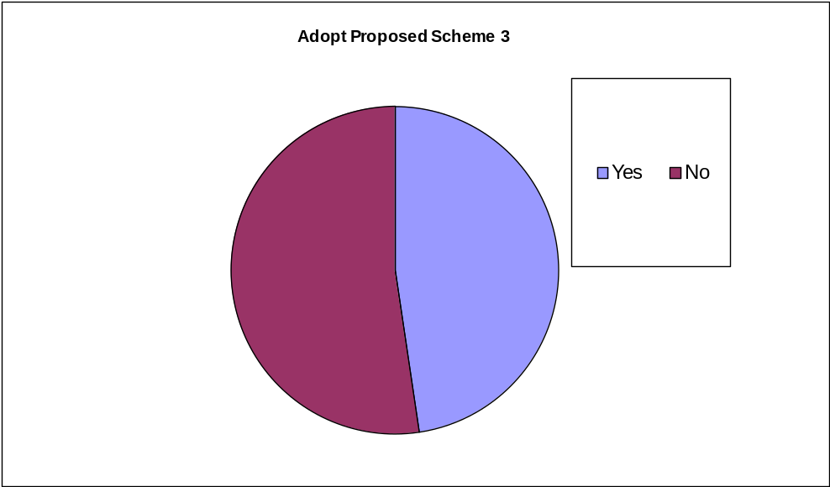

Adopt Proposed Scheme 3 | Number | Percentage  (of 230%)
Yes | 90 | 39%
No | 99 | 43%
Blank | 41 | 18%

Q: Which of the following groups do you think will be disadvantaged by Proposed Scheme 3?

Respondents were given the opportunity to select more than one group.

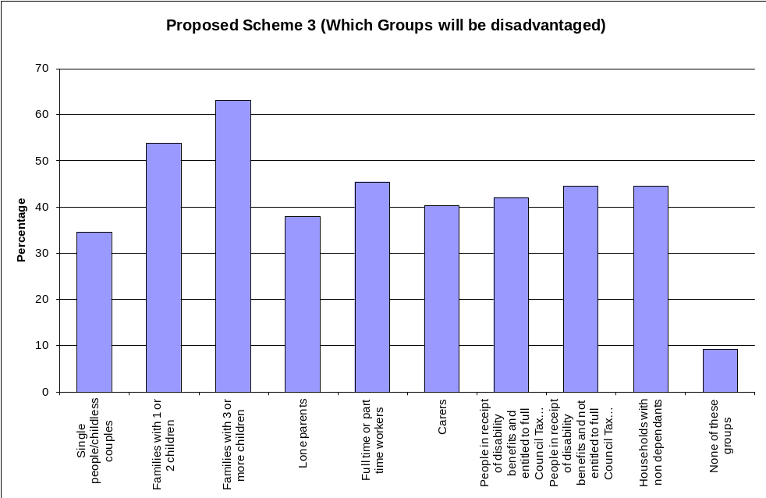

Group | Total | Percentage
Group | Total | (of 119)
Number of responses | 119
Families with 3 or more children | 75 | 63%
Families with 1 or 2 children | 64 | 54%
Full or part time workers | 54 | 45%
People in receipt of disability benefits and not entitled to full Council Tax Support | 53 | 45%
Households with non dependants | 53 | 45%
People in receipt of disability benefits and entitled to full Council Tax Support | 50 | 42%
Carers | 48 | 40%
Lone parents | 45 | 38%
Single people/childless couple | 41 | 34%
None of these groups | 11 | 9%

The top three groups identified as being impacted by proposed scheme 3 were:

- Families with 3 or more children
- Families with 1 or 2 children
- Full or part time workers

Q: Thinking about the groups which you have ticked ‘yes’ for above, please tell us why you think they will be affected.

Given the large volume of feedback to this question, the responses are included in full in Appendix C. The Table below gives a summary by topic of responses relevant to the question.

Scheme 3 | Why you think they will be affected | Number
1 | Affects families the most | 12
2 | Impacts on vulnerable/disabled/those on benefits forced to cut other things | 10
3 | Affects all groups financially | 7
4 | Households with non-dependents due to increased deductions | 7
5 | Those on Child Benefit as included as income | 7
6 | Workers due to earnings disregard and minimum support band | 6
7 | This scheme relatively better for Working Age Disabled | 5
8 | For the financial reasons shown in Booklet Chart 4 | 3
8 | This scheme makes smaller reductions for the largest proportion of claimants | 3
9 | Families will have to pay more/need more support | 3
10 | Impact on part timer workers – no money | 3
11 | This scheme protects the Disabled better than the others | 2
12 | Family size is a matter of choice whereas benefits are meant to make up to a basic living standard so should not be used in Council Tax Support | 2
13 | Still forces Disabled to pay more | 1
14 | Impact on lone parents – no money | 1
15 | Scheme is fairest to Carers | 1
16 | Impact on those who can’t work - Carers, parents with young children and Disabled | 1
17 | Should include all income other than disability benefits | 1

The three most common reasons given as to why the identified groups are affected by Proposed Scheme 3 are:

1. Affects families the most
2 Impacts on vulnerable/disabled/those on benefits who will be forced to cut other things
3= Affects all groups financially
Households with non-dependents due to increased deductions
Those on Child Benefit as included as income

4.1.8 Question 1d

Q: Do you think Harrow Council should adopt Proposed Scheme 4?
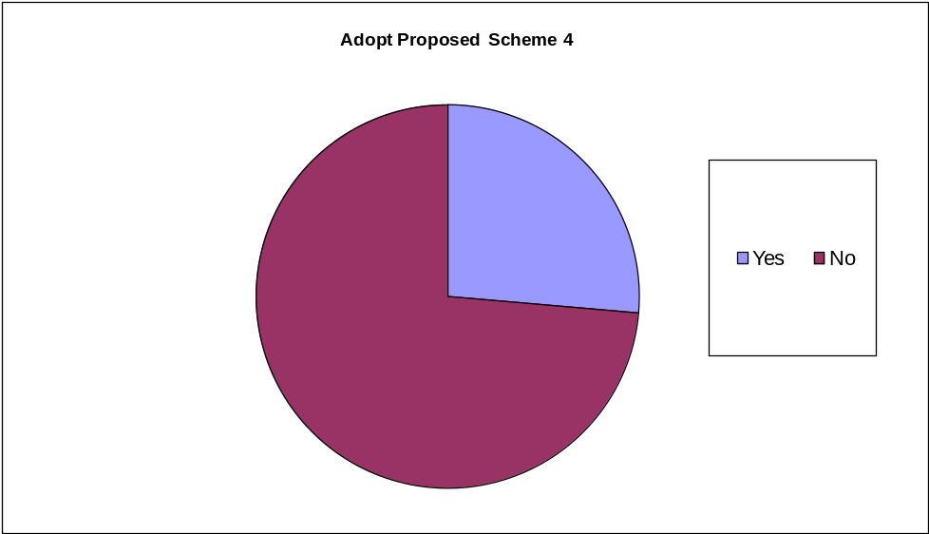

Adopt Proposed Scheme 3 | Number | Percentage  (of 230)
Yes | 48 | 21%
No | 134 | 58%
Blank | 48 | 21%

Q: Which of the following groups do you think will be disadvantaged by Proposed Scheme 4?

Respondents were given the opportunity to select more than one group.

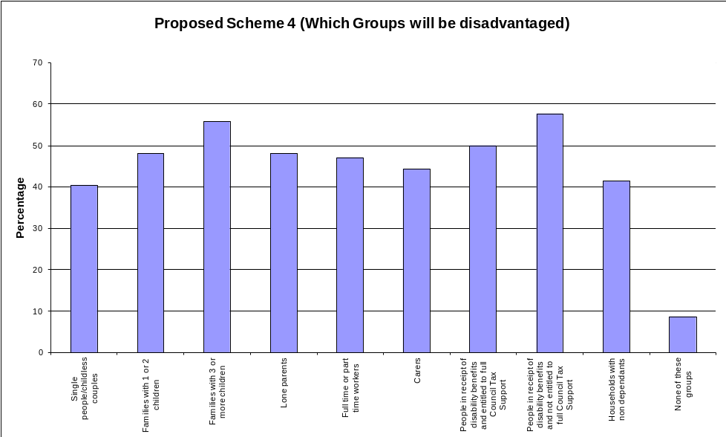

Group | Total | Percentage
Group | Total | (of 104)
Number of responses | 104
People in receipt of disability benefits and not entitled to full Council Tax Support | 60 | 58%
Families with 3 or more children | 58 | 56%
People in receipt of disability benefits and entitled to full Council Tax Support | 52 | 50%
Families with 1 or 2 children | 50 | 48%
Lone parents | 50 | 48%
Full or part time workers | 49 | 47%
Carers | 46 | 44%
Households with non dependants | 43 | 41%
Single people/childless couple | 42 | 40%
None of these groups | 9 | 9%

The top three groups identified as being impacted by proposed scheme 4 were:

- People in receipt of disability benefits and not entitled to full Council Tax Support
- Families with 3 or more children
- People in receipt of disability benefits and entitled to full Council Tax Support

Q: Thinking about the groups which you have ticked ‘yes’ for above, please tell us why you think they will be affected.

Given the large volume of feedback to this question, the responses are included in full in Appendix C. The Table below gives a summary by topic of responses relevant to the question.

Scheme 4 | Why you think they will be affected | Number
1 | Impacts on vulnerable/disabled/those on benefits who will forced to cut other things | 9
2 | Affects all groups financially | 8
3 | Affects families the most | 5
4 | Child Benefit is essential and should not be included | 4
5 | Affects Working Age Disabled (lower liability cap) | 4
6 | Impact of changes to those on low income | 4
7 | Forces Disabled to pay more | 3
8 | For the financial reasons shown in Booklet Chart 4 | 3
9 | Impact through increase in non-dependant deductions on households, carers and those unable to work | 3
10 | Impact on singles and couples of scrapping Additional Earnings Disregard | 2
11 | Many groups will be worse off than under other Schemes | 2
12 | Households with non-dependents least affected | 2
13 | Families need more support | 1
14 | Working Disabled should make a contribution | 1
15 | Carers and households with non-dependents will most disadvantaged | 1
16 | Council Tax Support should take into account all household income | 1
17 | Family size is a matter of choice whereas benefits are meant to make up to a basic living standard so should not be used in Council Tax Support | 1
18 | Workers due to earnings disregard and minimum support band | 1

The three most common reasons given as to why the identified groups are affected by Proposed Scheme 4 are:

- Impacts on vulnerable/disabled/those on benefits who will be forced to cut other things
- Affects all groups financially
- Affects families the most

4.1.9 Question 1e

Q: Are there other groups that we have not identified above that you think will be detrimentally affected by any of the proposed schemes?

Any other groups not already identified | Number | Pecentage
Yes | 33 | 14%
No | 101 | 44%
Blank | 96 | 42%

Q: Please tell us which groups these are and why you think they will be affected.

13 (52%) of the 25 responses given identified that those on low income/no income/Job Seekers Allowance /Employment Support Allowance would be affected by the Proposed Schemes.

The responses to this question are included in full in Appendix D.

Comparison of responses

A comparison of the responses to these initial questions has been brought together as follows:

Table 1: Comparison of Yes, No and No Response to Proposed

Scheme adoption | Scheme 1 | Scheme 2 | Scheme 3 | Scheme 4
Yes | 57 (25%) | 45 (19%) | 90 (39%) | 48 (21%)
No | 136 (59%) | 142 (62%) | 99 (43%) | 134 (58%)
Blanks | 37 (16%) | 43 (19%) | 41 (18%) | 48 (21%)

Table 2: Comparison of respondents views on Disadvantaged Groups affected by Proposed Schemes

Proposed Scheme | Most Disadvantaged Groups
Scheme 1 | 1. | People in receipt of disability benefits and not entitled to full Council Tax Support
Scheme 1 | 2. | People in receipt of disability benefits and entitled to full Council Tax Support
Scheme 1 | 3. | Families with 3 or more children
Scheme 2 | 1. | People in receipt of disability benefits and not entitled to full Council Tax Support
Scheme 2 | 2. | People in receipt of disability benefits and entitled to full Council Tax Support
Scheme 2 | 3. | Families with 3 or more children
Scheme 3 | 1. | Families with 3 or more children
Scheme 3 | 2. | Families with 1 or 2 children
Scheme 3 | 3. | Full or part time workers
Scheme 4 | 1. | People in receipt of disability benefits and not entitled to full Council Tax Support
Scheme 4 | 2. | Families with 3 or more children
Scheme 4 | 3. | People in receipt of disability benefits and entitled to full Council Tax Support

4.1.10 Question 2

Changes to Harrow’s Council Tax Support Scheme could be implemented in full from April 2015, or phased in over 2 or more years. If the changes were phased in, this will start from April 2015 but continue over a longer period. When do you think changes to the scheme should be implemented?

Q: In full from April 2015?

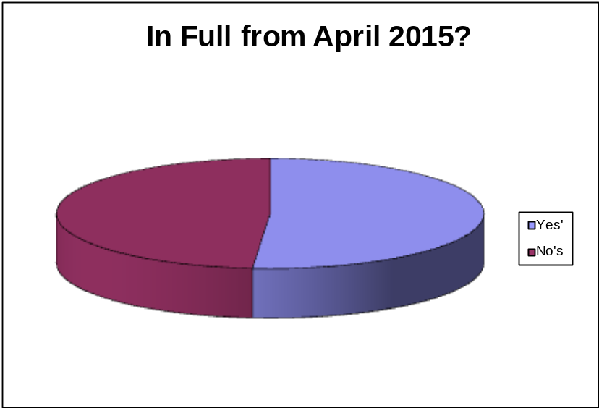

In full from April 2015 | Number | Percentage  (of 230)
Yes | 78 | 34%
No | 74 | 32%
Blanks | 78 | 34%

Q: Phased in over 2 or more years?

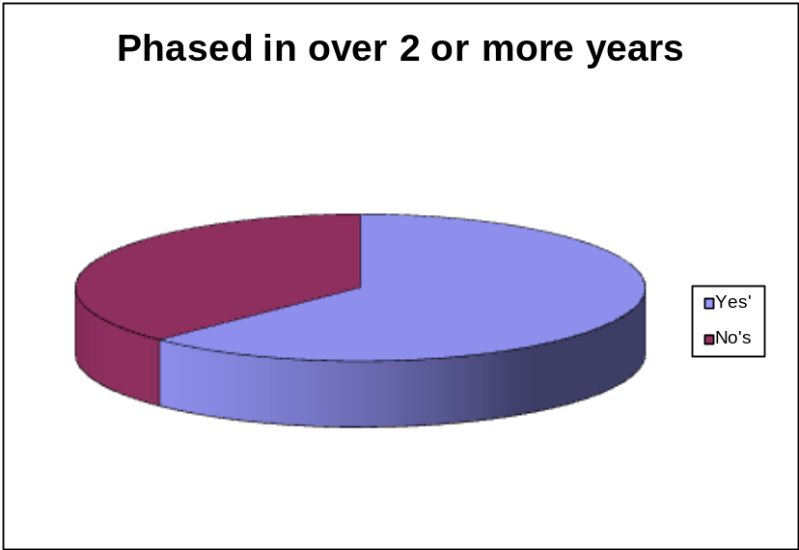

Phased in over 2 or more years | Number | Percentage  (of 230)
Yes | 93 | 41%
No | 56 | 24%
Blanks | 81 | 35%

Some respondents indicated ‘Yes’ for both phasing options and some chose neither.

4.2 Questionnaire Additional Comments

4.2.1 Those responding through the Questionnaire were invited in Question 3 to submit further comments on the proposed changes. Responses made by email are also collated here. The detailed responses received are listed in Appendix E and are summarised by topic in the Table below. It should also be noted that some responses are lengthy and cover a range of topics.

 | TOPIC | NUMBER OF COMMENTS
1 | Protect the vulnerable | 25
2 | Consultation process | 16
3 | Protect the disabled | 15
4 | Lack of affordability for the individual | 14
5 | Central government policy on welfare reform/benefits/bedroom tax/level of grant | 12
6 | Other Council services | 7
7 | Council Tax | 7
8 | Agree with taking action to balance books | 4
9 | Scheme should be scraped/there should be no subsidy at all | 4
10 | Scheme should incentivise work/keep additional earnings disregard | 4
11 | Increase non dependant deductions | 3
12 | No exemptions, all should pay something | 3
13 | More should be done to recover amount lost to fraud | 3
14 | Support working families | 3
15 | Harrow scheme is harsh compared to other boroughs | 2
16 | Increase tax on those with higher income, not the poorest | 2
17 | Should not include benefits | 2
18 | View decision as already made | 2
19 | Include pensioners | 2
20 | Keep things as they are | 2
21 | Do not support any of the Proposed Schemes | 2
22 | Savings should come from other Council services | 1
23 | Difficult to find work | 1
24 | Remove additional earnings disregard | 1
25 | Include Child Benefit | 1
26 | Leave Child Benefit alone | 1
27 | No reduction for families | 1
28 | Scheme should be more generous | 1
29 | Other | 19

4.2.2 Focusing purely on those comments related to the Council Tax Support consultation proposals the 3 comments most commonly made were:

- Protect the vulnerable
- Protect the disabled
- Lack of affordability for the individual
4.3 Event Feedback

4.3.1 At each of the 31 Drop-in events and focus groups, comments from those attending were recorded and are listed in full in Appendix G. These have been summarised by topic in the Table below.

 | TOPIC | NUMBER OF COMMENTS
1 | Lack of affordability for the individual | 43
2 | Other Council services | 31
3 | Central government policy on welfare reform/benefits/bedroom tax/level of grant | 30
4 | Consultation process | 30
5 | Why is it people at the bottom of the ladder who are hit? | 9
6 | Council Tax | 9
7 | View decision as already made | 8
8 | Protect the disabled | 8
9 | All scheme options are bad/no option to choose none of the schemes | 8
10 | Challenge the basis for the £2m savings from Council Tax Support /should come from other Council services | 7
11 | Councillors pay/expenses | 6
12 | Impact of reducing income on families/working families | 5
13 | Harrow scheme is harsh compared to other boroughs | 5
14 | Include pensioners | 4
15 | Scheme should incentivise work/keep additional earnings disregard | 4
16 | Protect the vulnerable | 3
17 | More should be done to recover amount lost to fraud | 3
18 | Scheme 3 preferred (1 a collective show of hands at meeting) | 3
19 | Support working families, not benefits recipients | 3
20 | Should not include Child Benefit as income | 3
21 | Disabled people on higher income should pay more | 2
22 | There should be no exemptions, all should pay something | 2
23 | Increase non dependant deductions | 1
24 | Respondents will choose answer that is favourable to them | 1
25 | Scheme 1 preferred | 1
26 | Scheme 2 preferred | 1
27 | Merge Scheme 3 and 4 | 1
28 | Liability cap is too high | 1
29 | Unemployed should not have to pay | 1
30 | Difficult to find work | 1
31 | Young people will be affected the most | 1
32 | Should not include disabled income at all | 1
33 | If economy improves will changes be reversed? | 1
34 | Other | 43

4.3.2 Focusing purely on those comments related to the Council Tax Support consultation proposals the 3 comments most commonly made are listed below with quotes from people who held these views.

- Lack of affordability for the individual
I am not some lout who has not worked & claim money to spend on there "habits". It is ridiculous I can barely manage - take more from footballers, actors, MPs etc. and give to the people who need! Would you like to be a toilet attendant earning a pittance? Madness!! Because I was born in 1954 must now wait another 6 yrs until my pension!

I already have £2000 arrears of Council Tax that I am trying to clear. An extra payment of £25 to £30/month to be paid to the Council is virtually impossible! I have a lot of stresses at present and this extra added pressure will NOT help me at all

- Why is it people at the bottom of the ladder who are hit?
How can you target the poorest and most vulnerable members of society (unemployed, single parents, disabled) etc. why don't you start by cutting the pay of the highest earners a the council (managers councillors advisors and sundries) get rid of the mayors car + office, forget black history week or white history week if you ever have one (its divisive and racist) stick to the basic - rubbish clearing - road maintenance - street lighting etc. Cancel your glossy magazine.

I feel yet again that people on low income or benefits are being discriminated against.
It is appalling that the council is making any cuts what so ever to the council tax support scheme when it will be directly, negatively affecting the quality of life for our poorest and most vulnerable residents. I would much rather a disabled person or single mother had enough money to eat & heat their homes than look at the frivolous waste of tax payers’ money such as the new paving in harrow town-centre - This council have their priorities all wrong!

- Protect the disabled/All scheme options are bad
People with disabilities and long term health conditions should be given more care and concern then people who are able to walk and are healthy this is because disable people can't work to afford high rates of council tax they rely solely on the benefits they receive whilst other groups are able to pay high rate because they have a steady income can afford it through work.

Lack of council tax support will be most detriment to disabled people who are already dependent on benefit which has already been cut a lot

4.4 Formal Stakeholder Feedback

4.4.1 Formal responses have been received from the following organisations and are included in full in Appendix H.

- Harrow Citizen’s Advice Bureau
- Harrow Law Centre
- Harrow Mencap
- Zacchaeus 2000 Trust (Z2K) (please note that Appendix E, Questionnaire Additional Comments includes this response as an online response from Z2K and CPAG)
- Greater London Authority
4.4.2 Given the detailed nature of these formal responses, this section of the report only summarises the key issues raised.

Organisation | Summary of Key Issues
Harrow CAB | - Do not like any of the Proposed Schemes  - Would prefer a phased approach  - Keep Liability Cap differential for disabled claimants  - Do not include Disability Benefits as income  - Restrict Child Benefit income to families with more than 1 child  - Drop the Additional Earnings Disregard  - Do not increase minimum Council Tax Support cut-off  - NDDs should start at existing level and increase for higher earners
Harrow Law Centre | - Unable to support any of the Proposed Schemes as all are likely to place the most vulnerable into debt, homelessness and destitution; the schemes will not protect the vulnerable  - All the suggested groups will be disadvantaged  - The Harrow Council Tax Support scheme goes significantly beyond the level of cuts imposed by central government  - Harrow has the harshest scheme in the UK  - Proposals will extend the levels of uncollected Council Tax  - Found consultation both complex and misleading (in terms of previous years underspend)  - A number of case examples are set out  - Child benefit and disability benefits should not be included as income
Harrow Mencap | - Unable to support any of the Proposed Schemes  - Impact on vulnerable disabled people  - Lack of affordability for the individual  - Concerned that all schemes raise the liability cap for working age disabled people  - Disability Benefits should not be included as income  - Child benefit should not be included as income as it will disproportionately impact on BMER community  - Counting Disability Benefit as income will decrease the income taken into account for fairer charging, so no net gain  - Concern that collection rates will decline further
Zacchaeus 2000 Trust | - Unable to support any of the Proposed Schemes  - All the suggested groups will be disadvantaged, with low income workers, disabled people and large families affected the most  - Do not want the changes implemented at all  - Lack of affordability for the individual  - Impact on vulnerable disabled people  - Harrow has the harshest scheme in the UK  - Proposals will extend the levels of uncollected Council Tax  - Found consultation misleading in terms of previous years underspend  - Disability Benefits should not be included as income  - Concern over raising minimum support level and abolishing Additional Earnings Disregard, impacting on work incentives  - Concern over impact on children, lone parent families and large families  - Child benefit should not be included as income  - Impact assessment needed that takes full account of evidence from the 1st year of the scheme on arrears rates, cost of collection and other impacts  - Harrow should abolish minimum payment and reinstate 100% Council Tax Support as done in 7 other boroughs
Greater London Authority | - Procedural matters  - Collection rates

4.5 Petition

4.5.1 As a response to the consultation, Harrow Council has received a petition from residents regarding the proposed changes to the Council Tax Support scheme. The petition is signed by 411 people. A copy of the petition, and the covering letter from Zacchaeus 2000 Trust (Z2K) and the Child Poverty Action Group (CPAG), are included in Appendix J.

4.5.2 The petition states:

‘We the undersigned are opposed to Harrow Council’s decision to tax the benefit of thousands of disabled and unemployed residents. We note that Harrow’s 30 percent ‘Minimum Payment’ of Council Tax is already the highest in London and that now Councillors are proposing to increase that charge, by including disability benefits and child benefit in the calculation.

We understand that this policy is driven by the Coalition Government’s policy of ‘localising’ Council Tax Benefit and the 10 per cent cut in funding, but note that Hammersmith & Fulham, Kensington & Chelsea, Merton, Tower Hamlets, Wandsworth and Westminster have all decided against taxing their poorest residents and so we call on councillors in Harrow to withdraw this new ‘Poll Tax’.’

5. MONITORING INFORMATION

5.1 About You

5.1.1 The Questionnaire asked respondents to confirm whether they appeared on the Council Tax Bill and/or were in receipt of Council Tax Support. The Tables below are based on the 184 paper responses only. This question was not asked online.

Q: Does your name appear on the Council Tax Bill for your household?
Is your name on the Council Tax Bill for your household? | Number | Percent
Yes | 157 | 85%
No | 8 | 4%
Don’t know | 7 | 4%
Blank | 12 | 7%

Q: Does your household receive Council Tax Support?
Does your household receive Council Tax Support? | Number | Percent
Yes | 86 | 47%
No | 68 | 37%
Don’t know | 13 | 7%
Blank | 17 | 9%

The Consultation Questionnaire invited respondents to provide a range of monitoring information, as detailed below. As with the questionnaire responses, the statistics here are a combination of the 230 paper and online responses.

5.2 Age
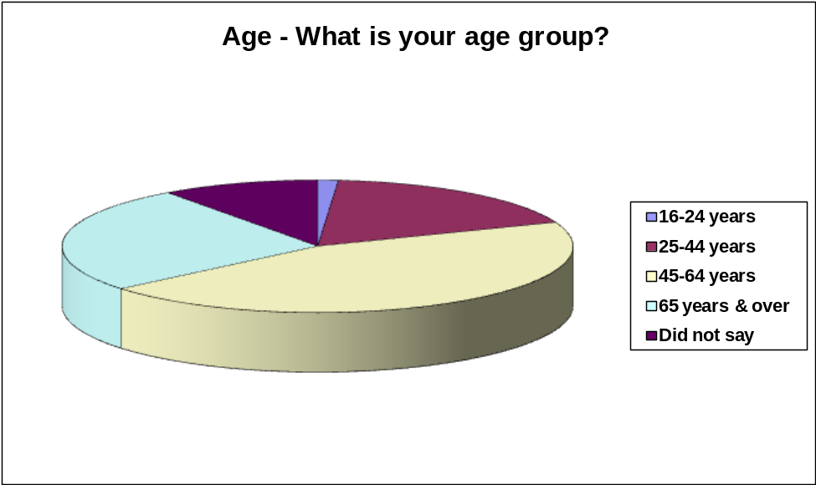

Figure X: What is your age group?

Q: What is your age group?
Age Group | Number | Percent
16-24 | 3 | 1%
25-44 | 41 | 18%
45-64 | 103 | 45%
65 years and over | 60 | 26%
Did not say | 23 | 10%

5.3 Disability
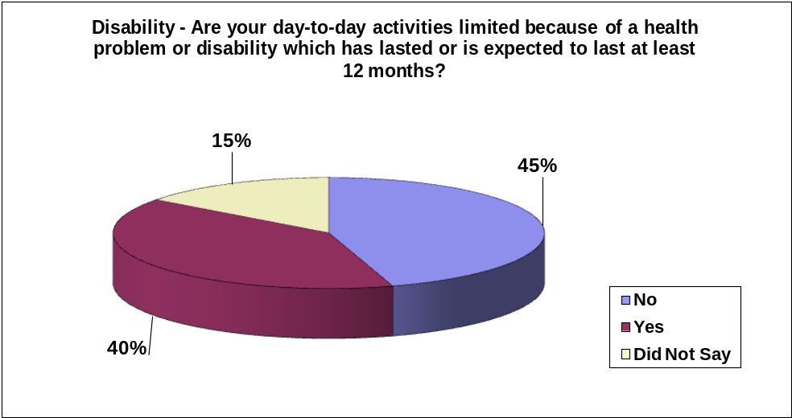

Q: Are your day-to-day activities limited because of a health problem or disability which has lasted or is expected to last at least 12 months?
Response | Detail | Number | Percentage
Yes |  | 92 | 40%
 | Affecting mobility | 50
 | Affecting hearing | 6
 | Affecting vision | 12
 | A learning disability | 22
 | Mental ill-health | 26
 | Another form of disability | 22
No |  | 104 | 45%
No response |  | 34 | 15%

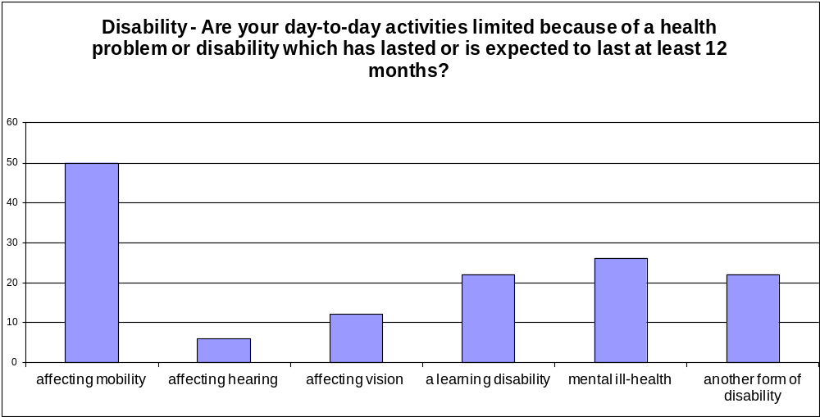

Q: If you have another form of disability, please specify:
Diabetic (3)
Asthma (2)
Arthritis (2)
Backpain, vertigo (1)
Kidney problem paralysis (1)
Heart patient (1)
Speech (1)
Back, feet, knee, neurology (1)
Stroke (1)
COPD breathing difficulties (1)
Trauma (post traumatic stress) (1)
Breathing, stroke, cancer (1)
Bowel disorder and joint problems (1)
Renal transplant and diabetes (1)
Chronic Hepatitus with liver cirrhosis (1)
Bipolar and severe depression and stress (1)
Parkinsons disease (1)
Dyspraxia (1)
Lung disease (1)

5.4 Ethnic Origin
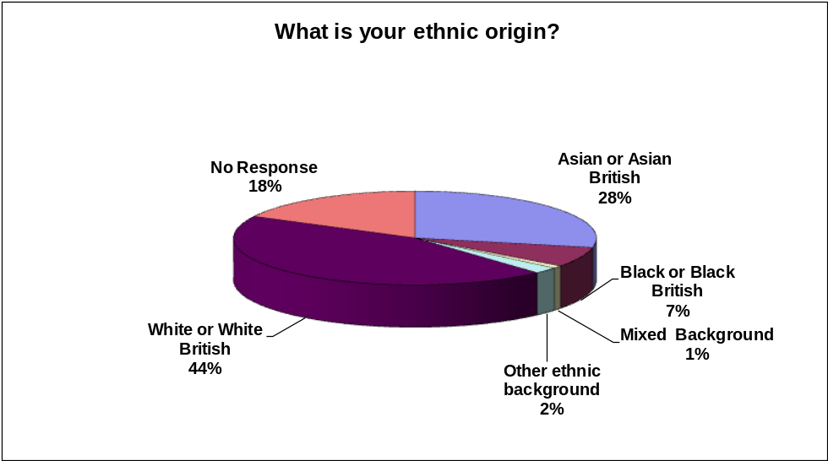

Q: What is your ethnic origin?
Ethnic Origin | Number | Percentage
Asian or Asian British | 65 | 28.2%
Black or Black British | 16 | 7.0%
Mixed Background | 2 | 0.9%
Other ethnic background | 5 | 2.2%
White or White British | 102 | 44.3%
No Response | 40 | 17.4%

Respondents were invited to further identify if they belonged to a specific group within their ethnic origin. Where a response was given, it is as tabulated below.

Ethnic Origin | Specific Group | Number | Pecentage
Asian or Asian British | Afghan | 5 | 2.7%
Asian or Asian British | Bangladeshi | 1 | 0.5%
Asian or Asian British | Chinese | 1 | 0.5%
Asian or Asian British | Indian | 35 | 18.8%
Asian or Asian British | Pakistani | 5 | 2.7%
Asian or Asian British | Sri Lankan | 13 | 7.0%
Asian or Asian British | Somali British | 1 | 0.5%
Asian or Asian British | Japanese | 1 | 0.5%
Asian or Asian British | Other (unspecified) | 5 | 2.7%
Black or Black British | African | 4 | 2.2%
Black or Black British | Caribbean | 7 | 3.8%
Black or Black British | Somali | 4 | 2.2%
Black or Black British | Other (unspecified) | 2 | 1.1%
Mixed Background | White and Black African | 1 | 0.5%
Mixed Background | White and Black Caribbean | 0 | 0.0%
Mixed Background | White and Asian | 2 | 1.1%
Mixed Background | Other (unspecified) | 2 | 1.1%
Other ethnic background | Arab | 1 | 0.5%
Other ethnic background | Iranian | 1 | 0.5%
Other ethnic background | Kurdish Iraq | 1 | 0.5%
Other ethnic background | Other (unspecified) | 1 | 0.5%
White or White British | Albanian | 0 | 0.0%
White or White British | English | 70 | 37.6%
White or White British | Gypsy/Irish Traveller | 1 | 0.5%
White or White British | Irish | 5 | 2.7%
White or White British | Polish | 2 | 1.1%
White or White British | Romanian | 0 | 0.0%
White or White British | Scottish | 1 | 0.5%
White or White British | Welsh | 1 | 0.5%
White or White British | Austrian | 1 | 0.5%
White or White British | British | 6 | 3.2%
White or White British | Kosovo | 1 | 0.5%
White or White British | Italian | 1 | 0.5%
White or White British | Other (unspecified) | 4 | 2.2%

5.5 Marriage or Civil Partnership
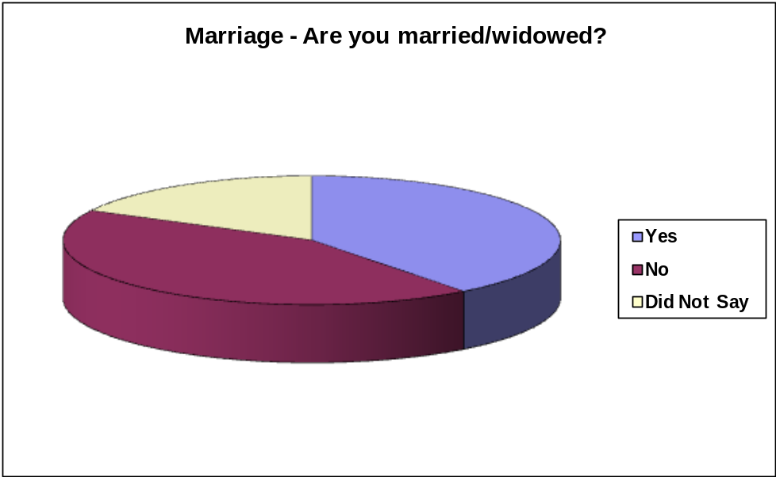

Q: Are you married/widowed?
Married/Widowed | Number | Percentage
Yes | 91 | 39.6%
No | 99 | 43.0%
Did not say | 40 | 17.4%

Are you in a Civil Partnership?
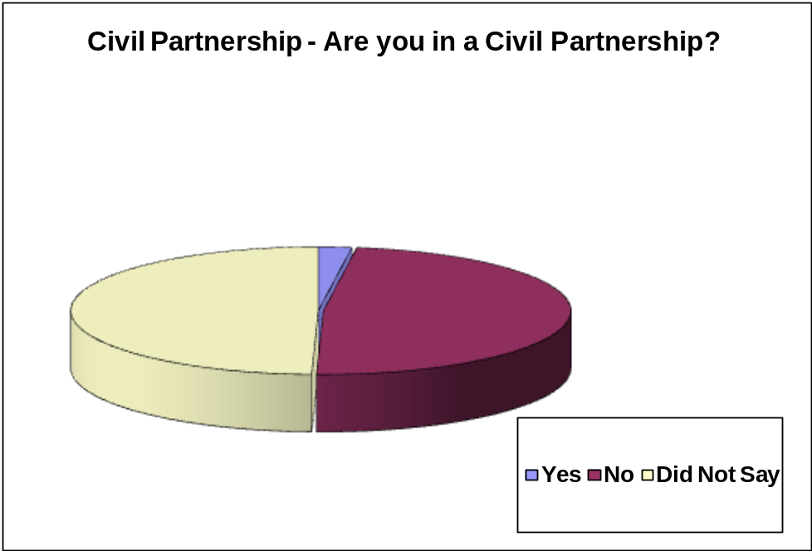

Q:
Civil Partnership | Number | Percentage
Yes | 5 | 2%
No | 111 | 48%
Did not say | 114 | 49%

5.6 Pregnancy or Maternity

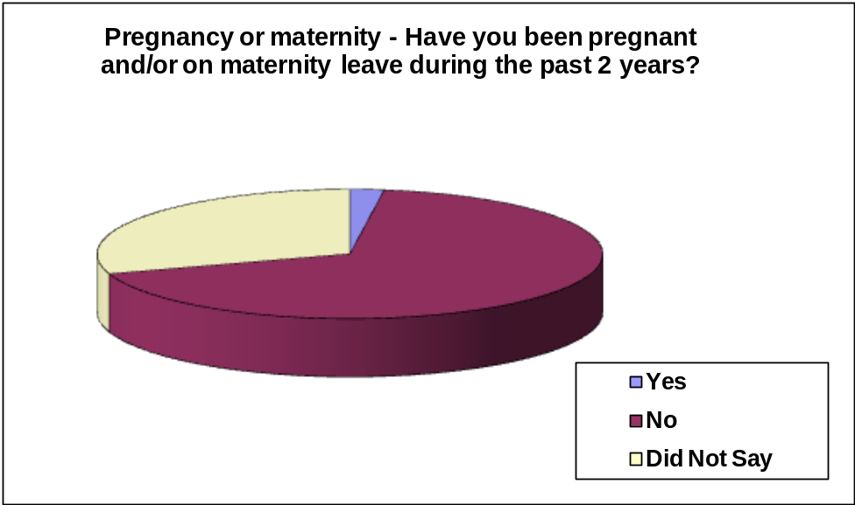

Have you been pregnant and/or on maternity leave during the last 2 years?
Have you been pregnant and/or on maternity leave during the last 2 years? | Number | Percentage
Yes | 5 | 2%
No | 156 | 68%
Did not say | 69 | 30%

5.7 Religion or Belief

What is your religion?

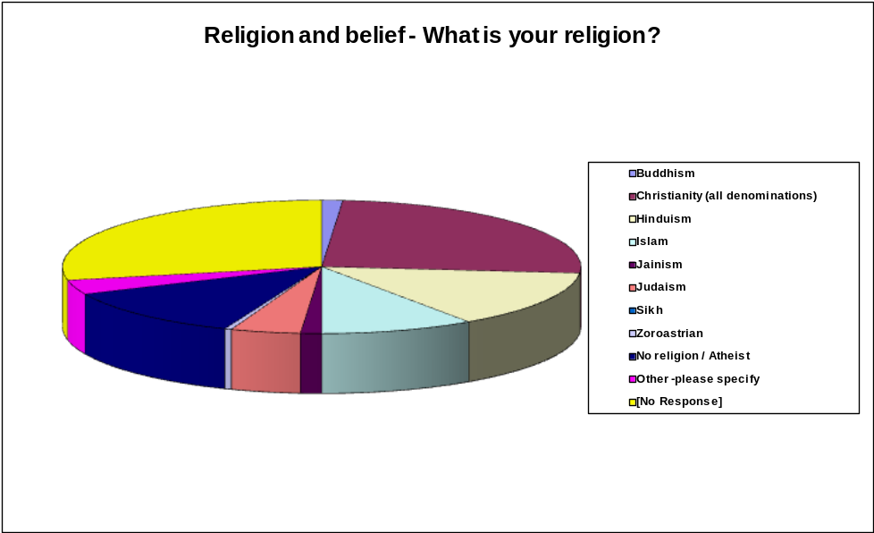

Religion | Number | Percentage
Buddhism | 3 | 1%
Christianity (all denominations) | 58 | 25%
Hinduism | 32 | 14%
Islam | 22 | 10%
Jainism | 3 | 1%
Judaism | 10 | 4%
Sikh | 0 | 0%
Zoroastrian | 1 | 0%
No religion / Atheist | 28 | 12%
Other | 8 | 3%
No response | 65 | 28%

5.8 Sex

Are you male/female?
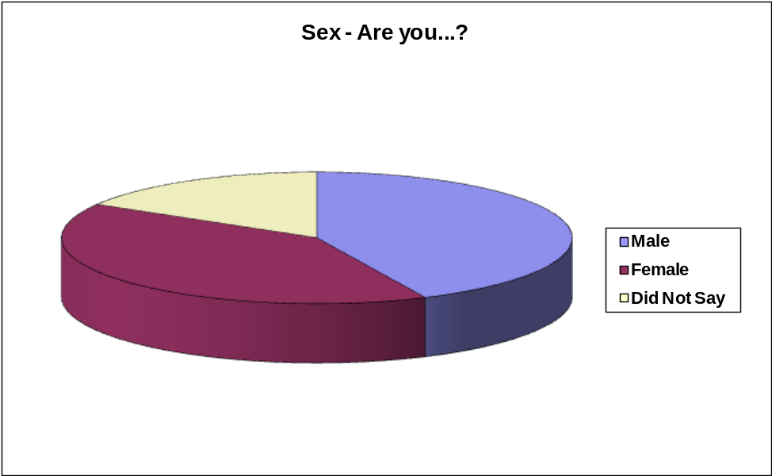

Male/Female | Number | Percentage
Male | 99 | 43%
Female | 93 | 40%
Did not say | 38 | 17%

5.9 Gender Identity
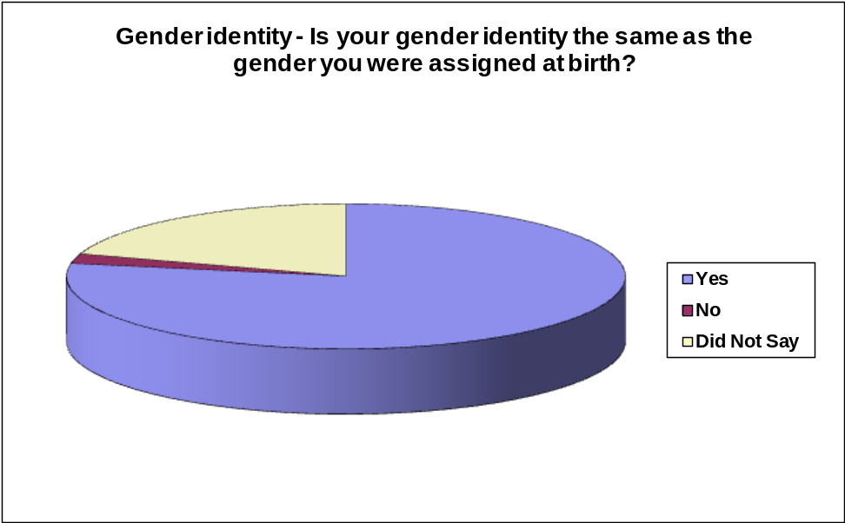

Is you gender identity the same as the gender you were assigned at birth? | Number | Percentage
Yes | 179 | 78%
No | 5 | 2%
Did not say | 46 | 20%

5.10 Sexual orientation

What is your sexual orientation?

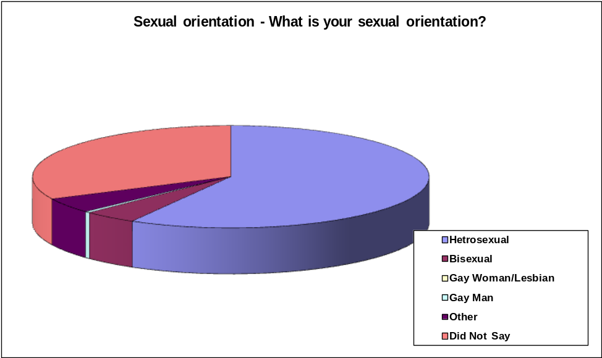

Sexual Orientation | Number | Percentage
Hetrosexual | 134 | 58%
Bisexual | 10 | 4%
Gay Woman/Lesbian | 0 | 0%
Gay Man | 1 | 0%
Other | 11 | 5%
Did not say | 74 | 32%

6. Next steps

The feedback from the consultation and the Equality Impact Assessment will be presented to Councillors at the Council’s Cabinet meeting in December 2014. Councillors will make their decision based on the feedback in a full Council meeting in January 2015.

Once a decision on whether savings are to be made from the Council Tax Scheme is known we will ensure that feedback is provided to Council Tax Support recipients, residents and stakeholders. If changes to the scheme are agreed an awareness campaign will be developed alongside the multi-agency Community Reference Group to ensure all Council Tax Support recipients understand what the changes will mean to them individually.

